# Why is Radiology important?

Radiology is the branch of medicine concerned with the use of imaging to diagnose and treat medical conditions. In the realm of women's health, that means using scans to see inside the body. X-ray machines use X-ray radiation to create images.

[Radiology](https://umacglobal.com/products/mri/)is a crucial part of the diagnostic process. It's become an essential part of the diagnostic process in the medical field. Radiology, also called diagnostic imaging, is a diagnostic process involving X-rays and other imaging technologies to detect and diagnose diseases and other medical conditions.

Without radiology, a lot of diseases would go undetected, and people would go undiagnosed. Radiology is also used to monitor and diagnose diseases. Radiology is a professional medical field that deals with imaging of the human body.

[Radiology tests](https://umacglobal.com/products/x-ray/) are also used to help guide surgeons in carrying out surgical procedures. In addition, radiology tests are used to help evaluate the severity of injuries and the prognosis of patients with long-term medical conditions.

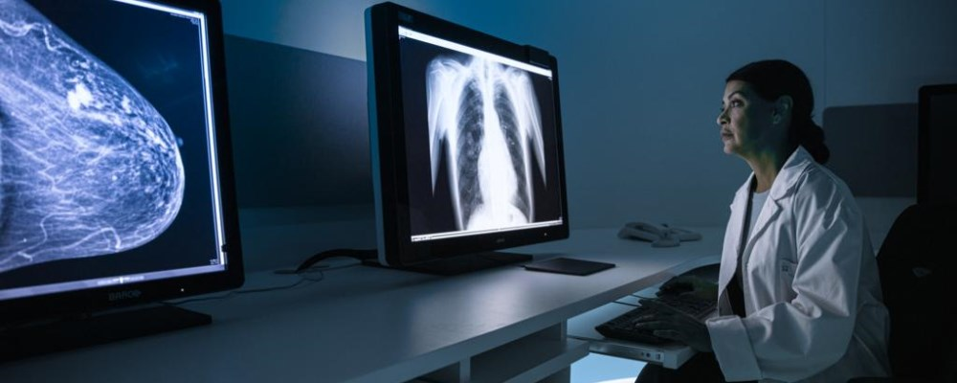

# How to become a Radiologist?

Radiologists are medical doctors who specialize in using X-rays, ultrasounds, MRIs, CT scans, and other forms of imaging technology to diagnose diseases. They are highly trained professionals who can interpret images and diagnose patients.

Becoming a radiologist is no easy task. The path to becoming a radiologist is rather straightforward and largely based on merit. If you want to become a radiologist, you need to get good grades in your undergraduate degree and get a medical degree.

 You'll need to get a bachelor's degree, which typically takes four years, a master's degree, which usually takes two years. Then you have to pass the American Board of Radiology exam. You'll also need to earn a master's degree in nuclear medicine or radiology.

Then, you'll need to complete a one-year internship or sometimes more and another year of residency training in radiology. During the training period, you'll work under the supervision of experienced radiologists.

# 

# Day in the life of an experienced Radiologist?

It takes years of hard work and dedication to become an experienced radiologist, and the life of a radiologist is not the same as other doctors. The radiologist carried out many activities in a day. Some of them are very critical and dangerous.

## Here are some activities that radiologist carried out in a day:

● Radiologists play a huge role in the world of medicine.

● They use their expertise and experience to interpret medical images, like X-rays, MRIs, CT scans, ultrasounds, and mammograms.

● Radiologists help doctors figure out what's going on inside the body when it isn't functioning properly.

● Radiologists perform ultrasound exams on pregnant women to determine the health of the fetus

● They perform imaging and blood tests to diagnose and treat various illnesses, including cancer, heart disease, infections, and other diseases.

# What is the future demand for Radiologists?

According to the US Bureau of Labor Statistics (BLS), the number of jobs for radiologic technologists and technicians will grow by 28% from 2012 to 2022. The BLS also reports that the median annual wages for radiologic technologists and technicians were $59,170 in May 2015.

The demand for medical imaging will continue to grow. Radiologists are the medical imaging industry leaders and will be in high demand in the future as the demand for radiology services continues to grow.

Radiologists are the doctors who administer and interpret x-rays, ultrasounds, MRIs, CAT scans, and other imaging technologies. These doctors are in high demand and are some of the highest-paid professionals in the medical industry.